How to define array of bits for 8051 in keil using C
You can define a single bit in Keil compiler very easily. For example the following code shows a single bit manipulation in Keil for 8051 microcontroller.
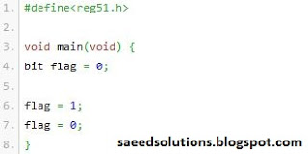

But if you try to define e-g bit bit_array[2]; then the compiler gives an error. Then how to define array of bits in Keil for 8051 microcontroller?
Consider the following code shown below.
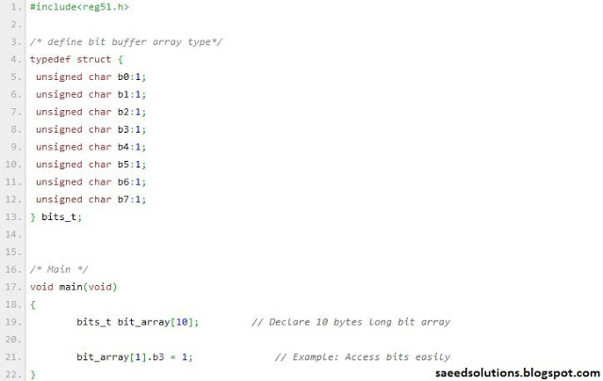
This code is defining a structure of bits_t which has 8 bits in it. These bits are defined as b0, b1, b2, b3 up to b7. Basically this structure occupies a single byte of type unsigned character in the memory and each of these bits are named to be b0, b1, b2 etc. You can access the bits simply by dot operator e-g bit_array[1].b3 will access bit3 of the bit_array[1] etc. The code above defines bit array of 10*8 = 80 bits. And you can easily access any bit of this array.
If you want to access the bits inside a loop then you can do this by making SetBit and GetBit functions. The following code demonstrates the use of these functions.
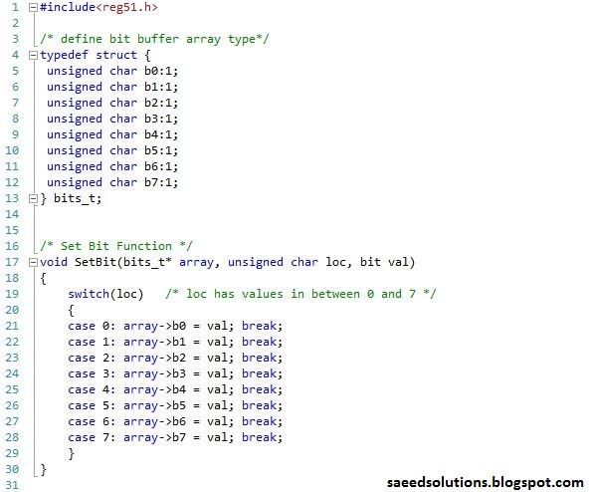
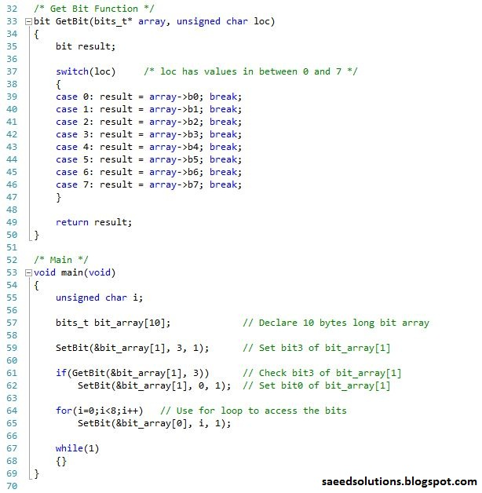
You can leave your comments in the comment section below.

